1 step
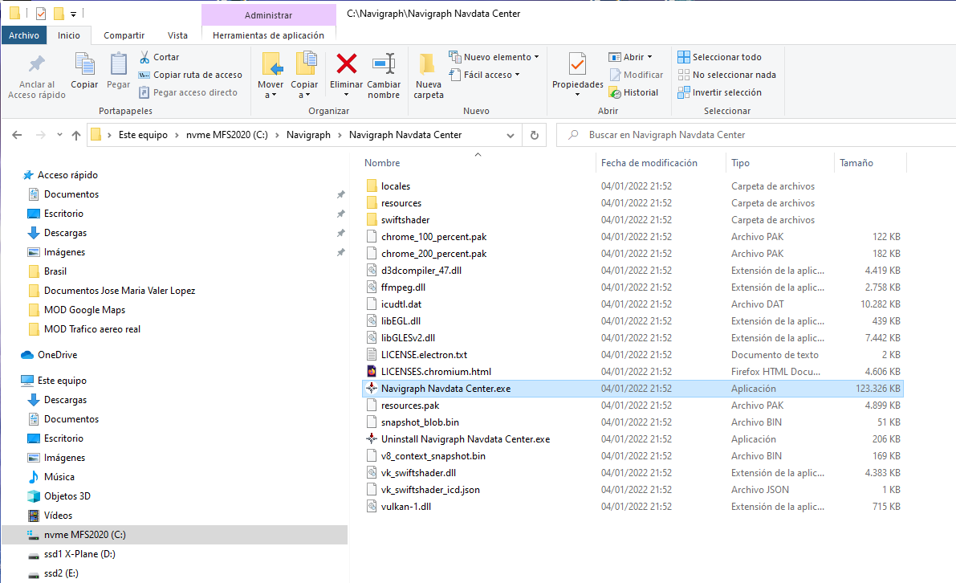

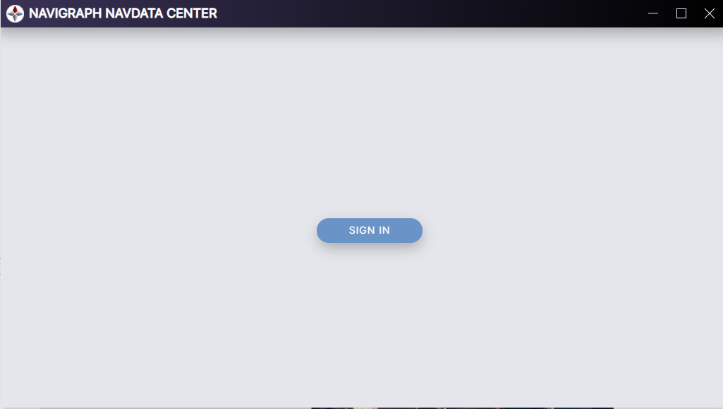
2 step

Press SIGN IN ……

3 step
https://identity.api.navigraph.com/connect/authorize?redirect_uri=navigraph-desktop%3A%2F%2Foidc_redirect_uri&client_id=navigraph-desktop&response_type=code&state=B64005xB0G&scope=openid%20charts%20fmsdata%20email%20userinfo%20offline_access&code_challenge=qhTLPngZJUfqitTEciB24_UDjviq97mQZOkHBBJR_jM&code_challenge_method=S256

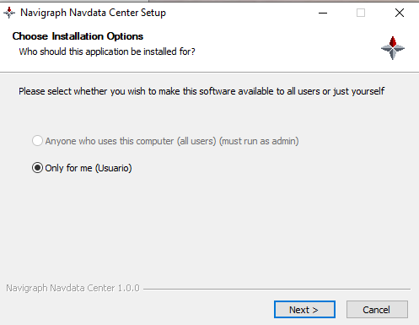
at the same time

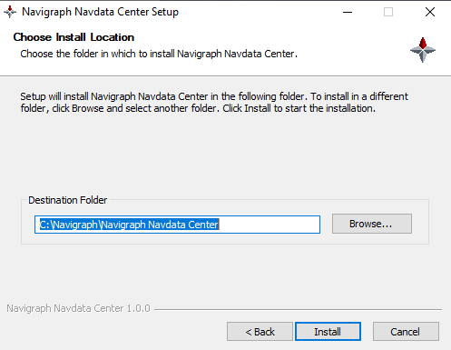
4 Step

then the loop starts

